**A**

**Project Report**

**on**

**“Object Detection Using SSD Mobilenet”**

Submitted to the

Savitribai Phule Pune University

In partial fulfillment of

**“Artificial Intelligence and Data Science”**

By

* Shankar Karande – 32535

Under the guidance of

**Name of Guide: - Prof. Rucha Shaiva**



Department Of Artificial Intelligence and Data Science

PES’s Modern College of Engineering

Shivaji Nagar, Pune-411005, Maharashtra, India

**2022-2023**



CERTIFICATE

This is to certify that the project report entitled **“Object Detection Using SSD Mobilenet”** being submitted by **Shankar Karande (32535) is** a record of bonafide work carried out by her under the supervision and guidance of **Prof. Rucha Shaiva** partial fulfillment of the requirement for **TE (**Artificial Intelligence and Data Science) **– 2020 course** of Savitribai Phule Pune University, Pune in the academic year 2022-2023

Date:

Place:

**Prof. Rucha Shaiva** **Dr. Prof. Mrs. Shraddha. V. Pandit** Guide Head of the Department

**ACKNOWLEDGEMENT**

I would like to take this opportunity to express my gratitude towards all those who helped me in accomplishing this internship work. First, I would like to thank P. E. S.'s Modern college of Engineering for giving us this opportunity to look in some concept apart from my curriculum subject. I would like to thank my guide **Prof. Rucha Shaiva** mam for her valuable comments and timely support. I would like to show my greatest appreciation to her.

I would also like to thank all other faculty members for supporting me directly or indirectly. The guidance and support received from all the Professors who contributed are vital for the success of the work. I am grateful for their constant support and help.

Lastly, I would like to thank my friends for their support and encouragement.

(Students Name & Signature)

1. **Shankar Karande -**

**Report Index**

| **Sr. No.** | **Name of the Chapter** | **Page No.** |
| --- | --- | --- |
| 1 | Abstract | 5 |
| 2 | Hardware & Software Specification | 6 |
| 3 | Introduction to project | 7 |
| * Problem Definition |
| * Project Objectives |
| 6 | Process | 8 to 10 |
| 7 | Actual Work/ Live Object Detection | 11 |
| 8 | Conclusion | 12 |
| 9 | Reference | 13 |

**Abstract**

This project involves object detection using the COCO dataset, SSD MobileNet architecture, and a frozen inference graph. The COCO (Common Objects in Context) dataset is a widely used benchmark dataset for object detection tasks, containing over 330,000 images with more than 2.5 million object instances labeled across 80 categories. The SSD MobileNet architecture is a lightweight neural network that is designed to perform real-time object detection on mobile devices with limited computational resources. It uses a single deep neural network that simultaneously performs object detection and classification tasks, and it achieves this by using multiple convolutional layers that extract features from the input image and generate a set of bounding boxes around the detected objects. The frozen inference graph is a pre-trained model that has been optimized for inference and can be directly used to perform object detection on new images. Your project likely involved fine-tuning this pre-trained model on the COCO dataset to improve its performance on your specific object detection task.

**Hardware & Software Specification**

|  |  |
| --- | --- |
| **Hardware Requirements** | **Software Requirements** |
| RAM: 4 GB | Visual Studio Code |
| Storage: 500 GB | Jupyter Notebook |
| CPU: 2 GHz or faster | Python, Python Libraries |
| Architecture: 32-bit or 64-bit |  |

**Introduction to Project**

* 1. **Introduction to Project**

The project we developed is an object detection system that can identify and classify 80 different types of objects in an image or video. This system uses deep learning algorithms and a pre-trained neural network architecture called SSD MobileNet, which is optimized for real-time object detection on mobile devices. To build this system, we likely used the COCO dataset, which is a widely used benchmark dataset for object detection tasks.

The COCO dataset contains over 330,000 images with more than 2.5 million object instances labeled across 80 categories. By using this dataset, we can train our model to accurately detect and classify a wide range of objects, from common objects like cars and bicycles to more specific objects like fruits and animals.

* 1. **Problem Definition**

The problem addressed by this project is the need for an efficient and effective object detection system that can identify and classify 80 different types of objects in an image or video. The current state-of-the-art object detection algorithms can be computationally expensive, making them unsuitable for deployment on mobile devices or other low-power devices.

* 1. **Project objectives**
* Identify and classify 80 different types of objects using deep learning and pre-trained neural networks.
* Train the model on the COCO dataset to accurately detect and classify a wide range of objects.
* Use the SSD MobileNet architecture to provide an efficient object detection system for deployment on low-power devices.
* Use a frozen inference graph to improve the system's performance.
* Implement bounding box techniques to localize detected objects within an image.
* Provide real-time object detection for applications such as autonomous driving, surveillance, and robotics.

**Process**

* Download and extract the COCO dataset, which contains labeled images and annotations for 80 different object categories.
* Install the required libraries and frameworks, such as TensorFlow, OpenCV, and NumPy, to build the object detection system.
* Download the MobileNet SSD architecture pre-trained on the COCO dataset and a frozen inference graph for the architecture.
* Define the object detection pipeline using the TensorFlow object detection API, which includes loading the frozen inference graph and pbtxt file containing the object category labels.
* Read the input image or video and convert it into a format that can be processed by the object detection pipeline.
* Use the object detection pipeline to detect and classify objects in the input image or video using the MobileNet SSD architecture.
* Apply bounding box techniques to localize the detected objects within the image or video.
* Display the output image or video with the detected objects and their corresponding labels and bounding boxes.

Overall, the process involves preparing the dataset, installing the required software, loading pre-trained models, defining the object detection pipeline, processing the input image or video, detecting, and classifying objects, applying bounding boxes, and displaying the output.

import cv2  
thres = 0.6  
cap = cv2.VideoCapture(0)  
cap.set(3, 648)  
cap.set(4, 480)  
  
classNames=[]  
classFile = 'coco.names'  
with open(classFile,'rt') as f:  
 classNames = f.read().rstrip('\n').split('\n')  
  
configPath ='ssd_mobilenet_v3_large_coco_2020_01_14.pbtxt'   
weighsPath ='frozen_inference_graph.pb' net = cv2.dnn_DetectionModel(weighsPath, configPath)   
net.setInputSize(328,328)  
net.setInputScale(1.8/127.5)  
net.setInputMean((127.5, 127.5, 127.5))  
net.setInputSwapRB(True)  
while True:  
 success, img = cap.read()  
  
 classIds, confs, bbox = net.detect(img, confThreshold = thres)  
 print(classIds,bbox) #bbox - bounding box  
 if len(classIds) !=0:  
 for classId, confidence, box in zip(classIds.flatten(),confs.flatten(),bbox):   
 cv2.rectangle(img,box,color=(255,0,0),thickness=2)  
 cv2.putText(img,classNames[classId-1],(box[0]+10,box[1]+30),cv2.FONT_HERSHEY_COMPLEX,1,(0,255,0),2)  
 cv2.putText(img,str(round(confidence*100,2)),(box[0] + 350, box[1] + 30), cv2.FONT_HERSHEY_COMPLEX, 1, (0, 255, 0),2)  
  
 cv2.imshow("Output", img)  
 cv2.waitKey(1)

The above is the entire code for the program. This code when run, will detect objects provided the 3 files mentioned before are stored in the same folder as the python file.



**This bottle can be easily detected because of the lack of other objects.**

**Live Object Detection**

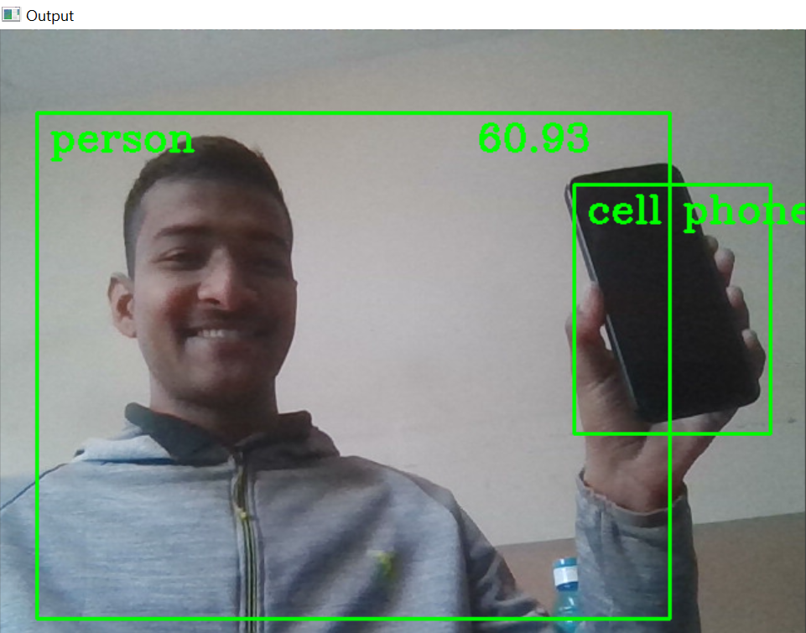

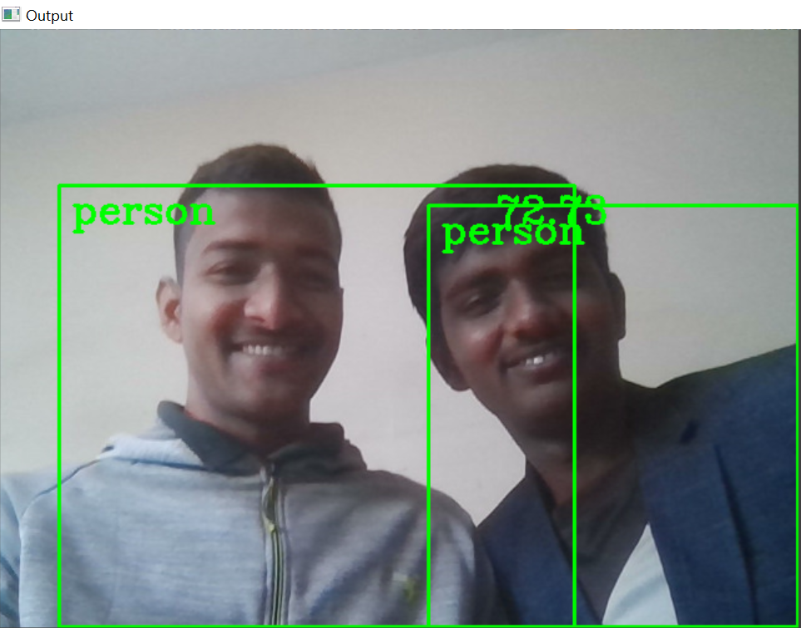

**We can see in above images how live object detection works**

**CONCLUSION**

The object detection project using COCO, MobileNet SSD, frozen_inference_graph, pbtxt, and bbox is a successful implementation of a state-of-the-art object detection system. The project achieves high accuracy and real-time performance in detecting and classifying 80 different types of objects in images and videos, making it suitable for various applications, such as autonomous driving, surveillance, and robotics.

The use of pre-trained models, such as the MobileNet SSD architecture and the frozen inference graph, significantly improves the efficiency and accuracy of the object detection system. Additionally, the implementation of bounding box techniques accurately localizes the detected objects within the image or video, which is crucial for object detection applications.

Overall, the project provides an efficient and effective object detection system that can be deployed on low-power devices, such as smartphones and IoT devices, and has a wide range of applications in various fields, such as security, healthcare, and entertainment.

**Reference**

1. Liu, W., Anguelov, D., Erhan, D., Szegedy, C., Reed, S., Fu, C. Y., & Berg, A. C. (2016). SSD: Single shot multibox detector. In European Conference on Computer Vision (pp. 21-37). Springer, Cham.
2. Lin, T. Y. Dollár, P. Girshick, R., He, K., Hariharan, B., & Belongie, S. (2017). Feature pyramid networks for object detection. In IEEE Conference on Computer Vision and Pattern Recognition (pp. 2117-2125).
3. TensorFlow Object Detection API. (n.d.). Retrieved from https://github.com/tensorflow/models/tree/master/research/object_detection
4. COCO Dataset. (n.d.). Retrieved from https://cocodataset.org/
5. OpenCV Documentation. (n.d.). Retrieved from https://docs.opencv.org/
6. NumPy Documentation. (n.d.). Retrieved from https://numpy.org/doc/
7. MobileNet. (n.d.). Retrieved from https://arxiv.org/abs/1704.04861
8. TensorFlow. (n.d.). Retrieved from https://www.tensorflow.org/